MODEL: STHT30AG30 - HOPPER TYPE SEMI-TRAILER  Body / Chassis:  Manufactured from high-strength steel by using special submerged welding machines. Chassis, frame and backbone structure are suitable for heavy-loads and difficult site conditions and designed for esthetic appearance and durability.  - Construction “Domex 700”  - Chassis “Domex 700”  - Goose-neck “Domex 700”  - Unloading hopper, “Domex 700”  - Upper filler caps ”Aluminum alloy”  - Hopper body “Aluminum alloy”  - Pneumatic botton unloading covers and mechanical safety locks  Axles:  - 3 axles, 12 ton capacity, square section  Front Axle Lifting :  Operated from the cab, protracting the tire life-cycle.  King-Pin :  2” bolt-connected in DIN Standards, interchangeable with 3.5”  Landing Legs :  “S 2000 plus” model telescopic landing legs mechanical with two speeds,  Dynamic: 25 000 kg,Static: 50 000 kg  Brake System :  - Dual circuit brake hardware  - 30” Service brake bellows  - 30x30” Emergency brake bellows  - Load balancing distribution valve  - Automatic brake adjusters  - EBS Brake System “WABCO”  Suspension System :  - Air -suspension “5813”  - 100 mm Z-type springs  - “WABCO” suspension valves  - Shock Absorbers  Electricity Hardware :  - 12/24 Volt Lighting System  - 7 pole distribution cable  - Electrical socket for lighting,  - 4 x 2 side lamps, | << All measures are declared with 2% margin >>  Dimensions :  - Total Length : 10,890 mm  - Total width : 2.550 mm  - Ground height : 3.800 mm  - Tare Weight : 6,700 kg  - Capacity : 33 m3  Tires : Bridgestone - Pirelli - Good Year  385 / 65 R 22.5” size, 6+1 units tubeless tires and steel rims.  Painting : All steel parts are painted with two layers of anti-corrosive primer coats and top acrylic colours.  Standard Accessories:  - 1 x spare tire holder  - FRP steel mudguards  - Aluminum ladder and barriers  - 1 x Tool box  - 1 x water tank “chrome nickel”  - Parking chock with handle.  Optional:  - Aluminum wheels  REMARK : Our products are under 2 years local and one year international warranty against manufacturing defects.  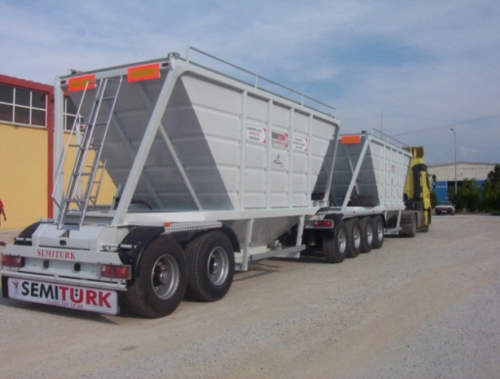  Required hardware for traffic.

